RAG Implementation pipeline
RAG – What actually happens in a RAG Pipeline?
Because Retrieval-Augmented Generation (RAG) systems facilitate the integration of Reasoning and Memory in a feedback loop, they mark a substantial shift from conventional methods of Language Model (LLM) creation. Traditional methods solely use the LLM's "parametric memory" knowledge found in the model's weight files as their main input source to generate a response. LLMs are therefore unable to "see" or directly access the files. As a result, LLMs produce output depending on the statistical likelihood that the output would be accurate. The RAG system, on the other hand, adds an external memory (often a vector database) as an extra memory source.
The documents kept in the vector database in a RAG system function as "live" sources of memory that you can access before an LLM generates a response. After retrieving a document from the vector database, the LLM examines its content and applies logic and reasoning to it before producing an LLM response.
As a result, the retrieval process for RAGs is very different from the retrieval process for a standard closed-book exam, when the student generates an answer to the test question only from memory. In an open-book exam, the student finds and consults only particular chapters or pages in the textbook that contain the relevant information required to provide an accurate and correct answer to the exam question, whereas in a closed-book exam, the student generates a response (the exam) solely from memory.
As a result, both RAGs alter our perception of LLMs, which are our primary source or sources of truth. The creation of academic projects, the engineering and development of AI systems, and other use cases where the output produced must be secure, verifiable, and traceable will undoubtedly be significantly impacted by this shift in the way LLMs operate. The documents kept in the vector database in a RAG system function as "live" sources of memory that you can access before an LLM generates a response. After retrieving a document from the vector database, the LLM examines its content and applies logic and reasoning to it before producing an LLM response.
Why Multimodal RAG (Text + Images) is a big deal?
The Multimodal RAG technology addresses some of the drawbacks of text-only retrieval systems that are frequently used in student projects by combining textual and image data into a single representation. This is a significant advancement because it enables the simultaneous retrieval of both text and images. Because some types of knowledge cannot be fully or accurately conveyed by text alone, text-only RAG systems do not always accurately convey all forms of knowledge (see image examples, such as wiring diagrams, flow charts, systems architecture, UI screenshots, medical scans, and engineering schematics).
Your system fills a gap in all current Text-Only RAG systems and gives it a competitive edge by embedding both text and image embeddings together in the same Semantic Space, as made possible by CLIP to encode the visual and textual components separately but within the same meaningful domain. By using CLIP, your system can create a relationship between text and images and analyse and process both at the Semantic Level.
By using CLIP, consumers are given a single frame of reference because the text and image information share a single Semantic Interpretation. When an example query is entered into the system to "Explain how Power is Distributed Through the Wiring Diagram," both the physical image of the wiring diagram and the relevant textual explanation are returned. This is more than just a feature; it is the true embodiment of "Multimodal Reasoning." In order to provide a more precise, thorough, and insightful answer to the user's query, the model can "reason" through both textual and visual content.
End to End RAG Flow
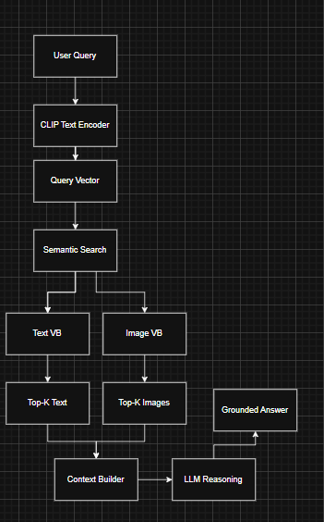
Figure 1: End-to-End RAG flow
The internal flow of the suggested end-to-end multimodal Retrieval-Augmented Generation (RAG) system is depicted in the diagram. The flow begins with a user-submitted natural language question that the CLIP text encoder transforms into a vector representation. A vector representation of the user's query that is, a vector representation of the query in a shared semantic space is the end product of the encoding process, which is similar for both texts and images.
A semantic similarity search is conducted against two parallel collections of vectors using the vector representation generated from the user's query: an image vector database made up of embedded images and a text vector database made up of embedded text document chunks. For each type of vector collection (i.e., text and image), the system gets a fixed number (Top K) of the most semantically related text segments and images. The prompt builder ensures that only pertinent and appropriate information based on the user's inquiry is included in the final context by combining the text segments and images retrieved from the corresponding collections into a single context.
In order to further minimise the possibility of any hallucinations or incorrect assumptions, the context provided to the LLM includes a comprehensive structure that allows the model to reason solely based on the content returned for the query. In order to demonstrate true multimodal reasoning, the system is built to directly deliver grounded and explicable responses based on the returned content (both text and image evidence), necessitating no access to the model's internal knowledge store.
Why vector DB?
A vector database functions more like memory than straightforward storage like a standard database since it may retrieve data based on the context in which it was placed. Finding results based on predetermined criteria precisely as stated is limited when using a typical database by searching for rows with certain column values that satisfy a set of criteria. On the other hand, the vector database uses the computed similarity between embeddings to do similarity searches and provide responses to comparable queries like "give me concepts that are similar to this thought."
This is how someone could create systems, such as Milvus, that function similarly to semantic memory, allowing you to store information and retrieve it conceptually based on its link to other things rather than using precise keywords. The vector database would give concrete context for the concept's origins, while the LLM would function as a semantic processor, the processor of reasoning and language development. Because the prefrontal cortex handles reasoning and decision-making and the hippocampus stores and retrieves memories, the architecture of Milvus provides a means of creating systems that function similarly to the human brain.

